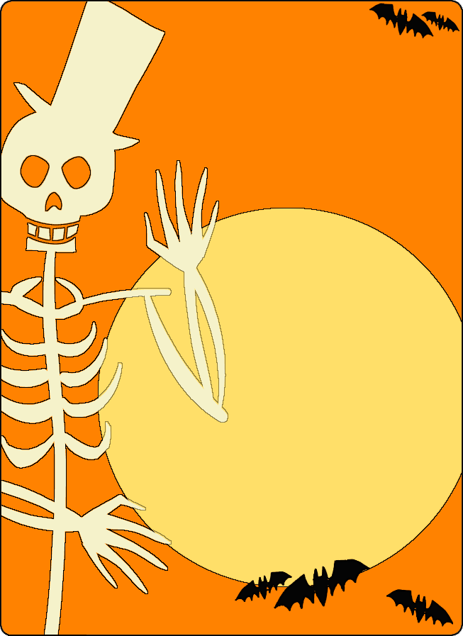
Family Halloween Party

Thursday, October 20, 2016

5:00pm-6:00pm

Fellowship House

Upper putt hut
We welcome you to join us for some ghoulish games, a costume contest, and sweet treats!
You must bring your kids or family member to attend!!!
Wear your costume!

